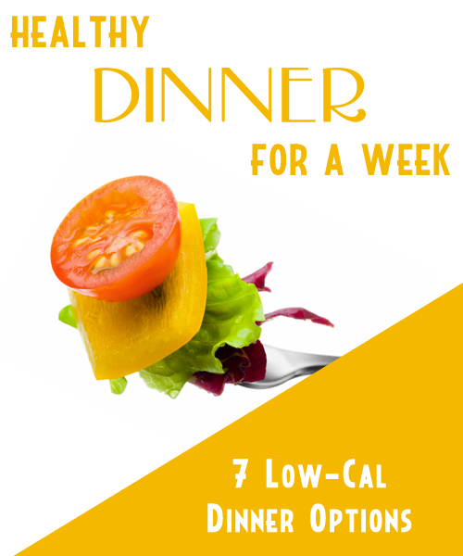
Table Of Contents

Tex-Mex Burger Wraps 3

Veggie Chili 3

Lime Chicken 3

Mushroom and Scallion Chicken 3

Broccoli And Shrimp 3

Southwest Steaks w/Salsa Sauce 3

Grilled Eggplant & Portobello Sandwich 3

Tex-Mex Burger Wraps

These quick burger wraps will be a sure fire hit and they are much healthier than their fast food cousins.

Ingredients

12 ounces lean ground beef
1 cup refried beans
1/2 cup chopped fresh cilantro
1 tbsp chopped pickled jalapenos
1 avocado, peeled and pitted
1/2 cup prepared salsa
1/8 tsp garlic powder
4 whole-wheat tortillas
2 cups shredded romaine lettuce
1/2 cup shredded pepper Jack cheese
1 lime, cut into 4 wedges

Directions

1. Preheat broiler. Coat a pan with light cooking spray.

2. Combine ground beef, beans, cilantro and jalapenos in a medium bowl.

3. Shape into four oblong patties and place on the prepared pan.

4. Broil the patties until done to your liking. Flip halfway through so both sides brow.

5. Mix avocado, salsa and garlic powder in a bowl.

6. Spread each tortilla with this mixture, then add lettuce and cheese.

7. Top each with a burger and roll into a wrap.

(Makes 4 Servings)

Calories Per Serving: 394
Veggie Chili

This hearty chili will please even the carnivores in your house.

Ingredients

1 small onion, chopped
1 large green bell pepper, chopped
3/4 cup chopped celery
3/4 cup dry red wine or water
3 cloves garlic, finely chopped
2 cans (14.5 ounces each) diced tomatoes, undrained
1 1/2 cups water
1/4 cup tomato paste
2 Vegetable Flavor Bouillon Cubes
1 tbsp chopped fresh cilantro
1 tbsp chili powder
1/2 tsp cumin
2 cans (15 ounces each) kidney beans, rinsed

Directions

1. Cook onion, pepper, celery, wine and garlic in large saucepan over medium-high heat until vegetables are tender.

2. Add tomatoes with juice, water, tomato paste, bouillon, cilantro, chili powder and cumin; stir well.

3. Stir in beans. Bring to a boil; cover. Reduce heat to low; cook, stirring occasionally, for 45 minutes.

(Makes 6 Servings)

Calories Per Serving: 210
Lime Chicken

This Asian inspired dish is also full of vitamins from the citrus.

Ingredients

Nonstick cooking spray
4 boneless, skinless chicken breast halves
3/4 cup Natural Apple Juice
Juice from 1 lime
2 tsp cornstarch
1 tsp Chicken Flavor Instant Bouillon

Directions

1. Spray large, nonstick pan with nonstick cooking spray.

2. Cook chicken, turning once, for 8 to 10 minutes or until no longer pink in center. Remove from pan and keep warm.

3. Combine Apple Juice, lime juice, cornstarch and bouillon in small bowl.

4. Add to skillet; cook, stirring occasionally, until thick. Spoon sauce over chicken to serve.

(Makes 4 Servings)

Calories Per Serving: 190
Mushroom and Scallion Chicken

Chicken is so versatile and boneless skinless chicken breast so healthy, that we had to bring you another tasty chicken recipe.

Ingredients

1 tbsp toasted sesame oil
1 small bunch scallions, sliced, whites and greens separated
1 small garlic clove, finely chopped
4 ounces shiitake mushrooms, stems removed and caps thinly sliced
4 cups water
1/4 cup low-sodium soy sauce
1 2-inch piece ginger, peeled and sliced
1 pound boneless, skinless chicken breasts, cut into 3/4 -inch cubes

Directions

1. In a very large soup pot, heat the sesame oil over medium heat.

2. Add the scallion whites and garlic; cook, stirring, about 1 minute. Add the mushrooms and cook until softened, about 3 minutes.

3. Pour the water into the pot. Add soy sauce and ginger. Let simmer for 2 minutes.

4. Place the chicken in the broth. Reduce heat to low; cover and poach until the chicken is just cooked through, about 7 minutes.

5. Transfer the chicken evenly to 4 bowls. Pour broth over the chicken. Garnish with the scallion greens.

(Makes 4 Servings)

Calories Per Serving: 190
Broccoli And Shrimp

An asian favorite, transformed in a quick and healthy dinner.

Ingredients

2/3 cup chicken broth
1 tsp cornstarch
1 tbsp minced garlic, divided
3 tsp extra-virgin olive oil, divided
1/4-1/2 tsp crushed red pepper
1 pound raw shrimp (21-25 per pound), peeled and deveined
1/4 tsp salt, divided
4 cups broccoli florets
2/3 cup water
2 tbsp chopped fresh basil
1 tsp lemon juice
Freshly ground pepper to taste
Lemon wedges

Directions

1. Combine chicken broth, cornstarch and half the garlic in a bowl; whisk until smooth.

2. Heat 1-1/2 tsp oil in a large nonstick pan over medium-high heat.

3. Add remaining garlic and crushed red pepper. Cook while stirring for about 30 seconds. Add shrimp. Sauté until shrimp are pink, about 3 minutes. Transfer to a bowl.

4. Add remaining oil to the pan. Add broccoli and a pinch of salt. Cook for 1 minute.

5. Add water, cover and cook until broccoli is crisp-tender, about 3 minutes. Transfer to the bowl with shrimp.

6. Add chicken stock mixture to the pan and cook, stirring, over medium-high heat, until thickened, 3-4 minutes.

7. Stir in basil and season with lemon juice and pepper. Add shrimp and broccoli; heat through. Serve with lemon wedges.

(Makes 4 Servings)

Calories Per Serving: 178
Southwest Steaks w/Salsa Sauce

These steaks pack a punch of power, use your favorite cut of meat, but we love the rib-eye.

Ingredients

2 4-ounce 1/2-inch-thick steaks, such as rib-eye, trimmed of fat
1 tsp chili powder
1/2 tsp kosher salt, divided
1 tsp extra-virgin olive oil
2 plum tomatoes, diced
2 tsp lime juice
1 tbsp chopped fresh cilantro

Directions

1. Rub both sides of steak with chili powder and 1/4 teaspoon salt.

2. Heat oil in a medium pan over medium-high heat. Add steaks and cook, turning once cook until it reaches your desired level of doneness. Cover steaks with foil and let rest while you make the salsa.

3. Add tomatoes, lime juice and remaining 1/4 teaspoon salt to the pan and cook, stirring often, until tomatoes soften, about 3 minutes.

4. Remove from heat, stir in cilantro and any accumulated juices from the steaks. Serve steaks topped with the salsa.

(Makes 2 Servings)

Calories Per Serving: 174
Grilled Eggplant & Portobello Sandwich

This vegetarian option is delicious and filling. It will be a crowd pleaser.

Ingredients

1 small clove garlic, chopped
1/4 cup low-fat mayonnaise
1 tsp lemon juice
1 medium eggplant (about 1 pound), sliced into 1/2-inch rounds
2 large portobello mushroom caps, gills removed
Canola or olive oil cooking spray
1/2 tsp salt
1/2 tsp freshly ground pepper
8 slices whole-wheat sandwich bread, lightly grilled or toasted
2 cups arugula, or spinach, stemmed and chopped if large
1 large tomato, sliced

Directions

1. Preheat grill to medium-high.

2. Mash garlic into a paste on a cutting board with the back of a spoon. Combine with mayonnaise and lemon juice in a small bowl. Set aside.

3. Spray both sides of eggplant rounds and mushroom caps with cooking spray and season with salt and pepper. Grill the vegetables, turning once, until tender and browned on both sides. When cool enough to handle, slice the mushrooms.

4. Spread 1 1/2 teaspoons of the garlic mayonnaise on each piece of bread. Layer the eggplant, mushrooms, arugula (or spinach) and tomato slices onto 4 slices of bread and top with the remaining bread.

(Makes 4 Servings)

Calories Per Serving: 209

